Introduction to Repetition

**Student ID**: 102721594

**Full Name**: Harrison Lim

Submit all of your written code and this file as a ZIP at the end of completion of this task.

# Resources

1. <http://doc.pyschools.com/html/whileloop.html>
2. <http://doc.pyschools.com/html/forloop.html>

# Tasks

1. Develop an algorithm and then code a program that counts from 0 to 25. Attach a screenshot of your algorithm below, and **add your code** to the ZIP once submitting.
   1. Each count will be displayed on a single line.
   2. 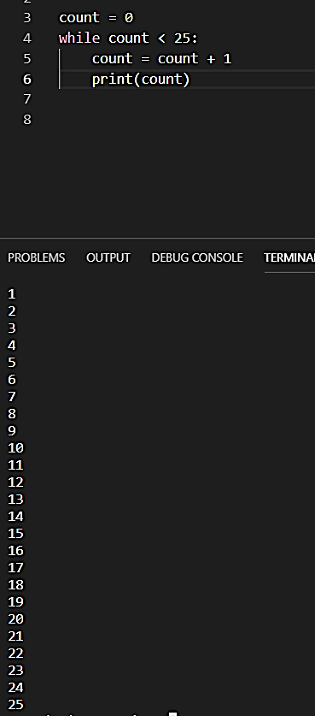Must use either a *for* loop or a *while* loop

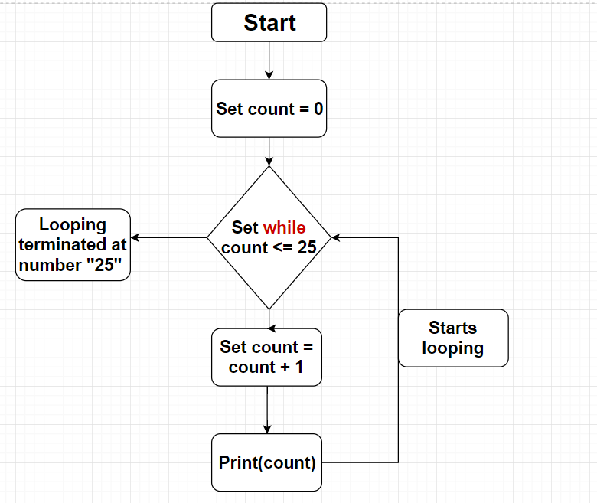

1. Develop another algorithm and then code a program that counts from 0 to 40, counting by twos. Attach a screenshot of your algorithm below, and **add your code** to the ZIP once submitting.
   1. Each count will be displayed on a single line.
   2. 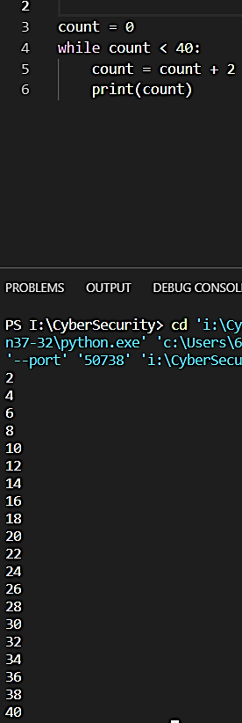Must use either a *for* loop or a *while* loop

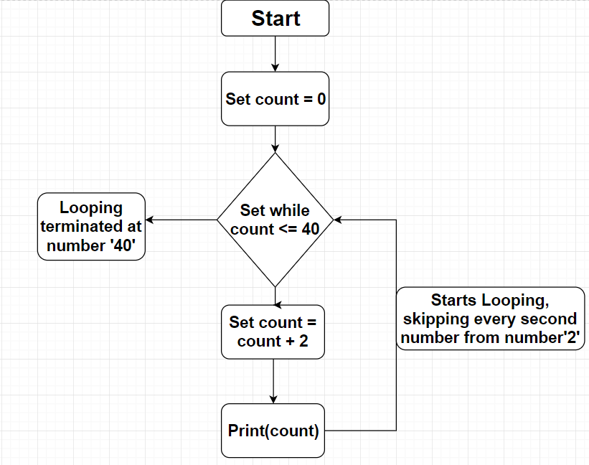

1. Develop another algorithm and then code a program that asks the user to enter a number, then sums all numbers from 0 to that number and displays the result. Attach a screenshot of your algorithm below, and **add your code** to the ZIP once submitting.
   1. Each count will be displayed on a single line.
   2. Must use either a *for* loop or a *while* loop

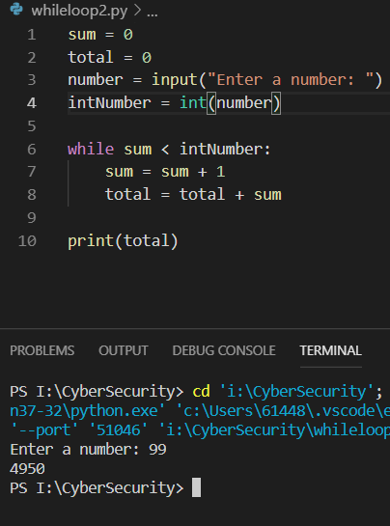

1. 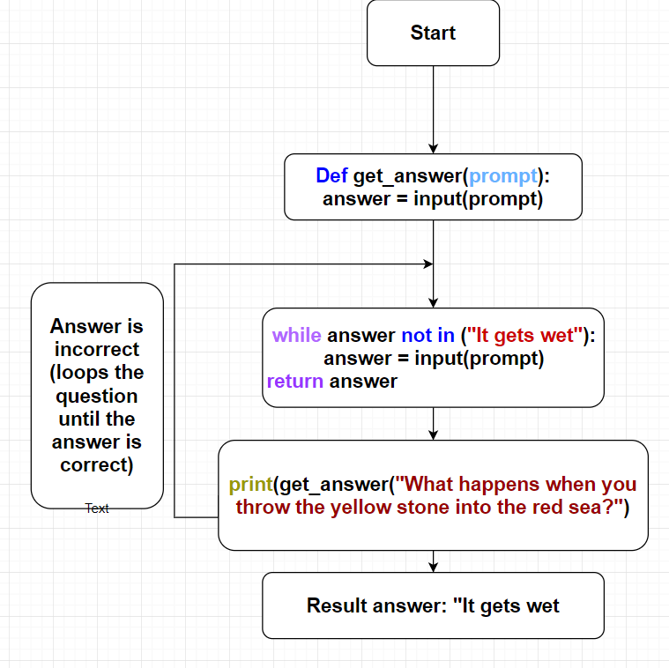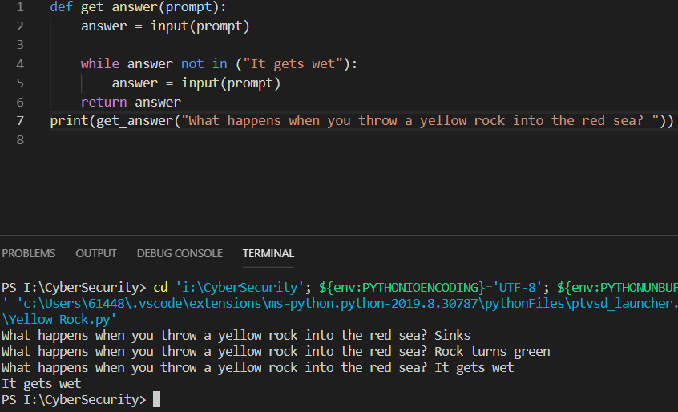Develop another algorithm and then code a program that asks the user "What happens when you throw a yellow rock in the red sea?". The user must guess the correct answer, "It gets wet". Attach a screenshot of your algorithm below, and **add your code** to the ZIP once submitting.